A groundbreaking effort led by Oregon-based nonprofit World Coffee Research (WCR) just delivered the most extensive real-world evaluation to date of how arabica coffee varieties stand up to their most relentless natural foe: coffee leaf rust.
Published in Frontiers in Plant Science, the study analyzed the natural performance of 29 arabica coffee varieties across 23 field sites in 15 countries.
Researchers found that while no single variety is universally immune to coffee leaf rust (CLR), several varieties demonstrated more consistent resistance across different environments. Conversely, some varieties showed high levels of resistance in some environments, and low levels in others, suggesting both variety and location play key roles in resistance to the crop-killing disease.
Global Collaboration
The open-access study was designed to offer valuable insight to coffee producers worldwide as coffee leaf rust remains a constant issue in nearly all the world’s coffee lands. Many farmers are still attempting to rebound from the coffee leaf rust pandemic that swept through Latin America beginning in 2012. The disease was first identified in the 19th century, and has since spread to all the world’s major growing regions, including most recently Hawaii in 2020.
The study grew from the World Coffee Research-led International Multilocation Variety Trial, a global network launched in 2015 to evaluate how coffee varieties perform under real-world conditions. Researchers from 18 countries established similar plots with 31 coffee varieties developed by 11 breeding programs. The sites ranged from dry zones in Zambia to humid, high-altitude farms in Indonesia.
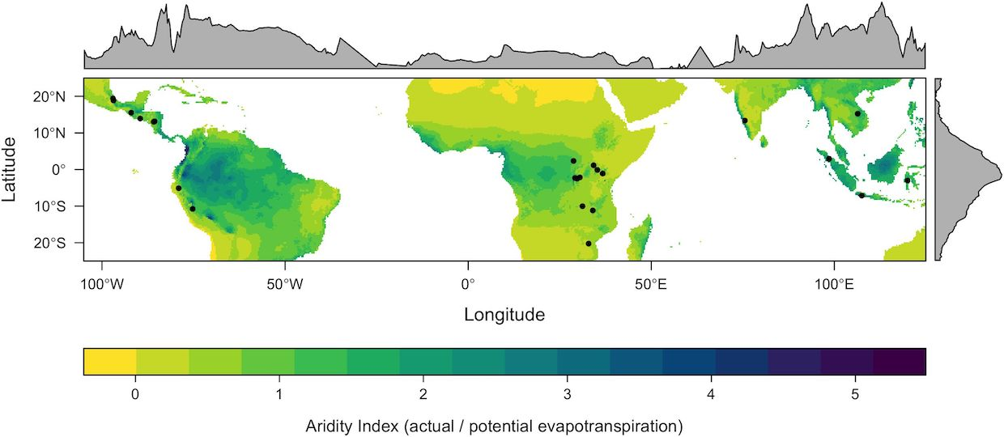
Location of the 23 study sites. The map shows the Priestley–Taylor α coefficient Aridity Index. Image shared via a Creative Commons Attribution License (CC BY). Find the original here.
“No single country or institution can solve the complex challenges facing coffee on its own,” Tania Humphrey, the scientific director of World Coffee Research, said in an announcement of the study’s publication. “This trial shows the power of global collaboration — by pooling data, expertise, and resources across continents, we’re able to generate insights that no single program could uncover alone. It’s a model not just for coffee, but for how agricultural science must evolve to meet the demands of a changing world.”
No Silver Bullet, but Promising Options
Among the top-performing arabica varieties were Parainema, Kartika 1, and IPR107, which showed relatively strong resistance and stable performance across diverse environments. Other varieties, like EC16 and Catigua MG2, had excellent resistance in specific locales, but were less consistent elsewhere.
In general, varieties containing genetic material from the Timor hybrid — an interspecific cross of arabica and robusta — outperformed pure arabica types. These Timor-derived cultivars contain a mix of resistance genes that help them fend off a wide range of leaf rust races, according to WCR.
Still, the study found that even resistant varieties showed some susceptibility, depending on local conditions, highlighting what scientists call strong “genotype-by-environment” interactions.
“By assessing the effects of variety, site and their interaction, we found that all three factors, as well as the block within the site, were highly significant,” the study authors wrote.

